Министерство образования и науки Российской Федерации

Севастопольский государственный университет

Кафедра ИС

Отчёт

по лабораторной работе№ 4

Разработка проекта с использованием системы контроля версий Git

Выполнил: Ст. Гр. ИС/б-42-о

Лисянский А. И.

Проверил:

Лагуткина Т. В.

Севастополь

2015

Цель работы

В соответствии с вариантом задания в команде реализовать проект с использование системы контроля версий Git.

Вариант задания

Проект «Калькулятор. Обычный».

Ход работы

Ссылка на проект:

https://github.com/sasha2567/For_Labs_IT_Management_Project

Разделение задач проекта между участниками:

Саша: интерфейс, операция сложения и деления, извлечение корня, квадрат числа, синус и косинус, кнопка ± и очистка поля ввода.

Артем: кнопки 0-9 и десятичный разделитель, операция минус и умножение, 1/х и кнопка «равно», тангенс, взятие процента.

Код выполнения в консоли Git

Welcome to Portable Git (version 1.9.5-preview20141217)

Run 'git help git' to display the help index.

Run 'git help <command>' to display help for specific commands.

Александр@DELL-HOME /e/lab4_it_projects (master)

$ touch readme.txt

Александр@DELL-HOME /e/lab4_it_projects (master)

$ git add .

Александр@DELL-HOME /e/lab4_it_projects (master)

$ git commit -m 'init'

[master (root-commit) 796468f] init

1 file changed, 1 insertion(+)

create mode 100644 readme.txt

Александр@DELL-HOME /e/lab4_it_projects (master)

$ git checkout -b Sasha

Switched to a new branch 'Sasha'

Александр@DELL-HOME /e/lab4_it_projects (Sasha)

$ git add .

warning: LF will be replaced by CRLF in bootstrap-3.3.5-dist/css/bootstrap-theme.css.

The file will have its original line endings in your working directory.

warning: LF will be replaced by CRLF in bootstrap-3.3.5-dist/css/bootstrap-theme.min.css.

The file will have its original line endings in your working directory.

warning: LF will be replaced by CRLF in bootstrap-3.3.5-dist/css/bootstrap.css.

The file will have its original line endings in your working directory.

warning: LF will be replaced by CRLF in bootstrap-3.3.5-dist/css/bootstrap.min.css.

The file will have its original line endings in your working directory.

warning: LF will be replaced by CRLF in bootstrap-3.3.5-dist/fonts/glyphicons-halflings-regular.svg.

The file will have its original line endings in your working directory.

warning: LF will be replaced by CRLF in bootstrap-3.3.5-dist/js/bootstrap.js.

The file will have its original line endings in your working directory.

warning: LF will be replaced by CRLF in bootstrap-3.3.5-dist/js/bootstrap.min.js.

The file will have its original line endings in your working directory.

warning: LF will be replaced by CRLF in bootstrap-3.3.5-dist/js/npm.js.

The file will have its original line endings in your working directory.

warning: LF will be replaced by CRLF in css/main.css.

The file will have its original line endings in your working directory.

warning: LF will be replaced by CRLF in js/jquery-2.1.4.min.js.

The file will have its original line endings in your working directory.

warning: LF will be replaced by CRLF in js/main.js.

The file will have its original line endings in your working directory.

warning: LF will be replaced by CRLF in main.html.

The file will have its original line endings in your working directory.

Александр@DELL-HOME /e/lab4_it_projects (Sasha)

$ git commit -m 'sasha`s task'

[Sasha 0b844d3] sasha`s task

warning: LF will be replaced by CRLF in bootstrap-3.3.5-dist/css/bootstrap-theme.css.

The file will have its original line endings in your working directory.

warning: LF will be replaced by CRLF in bootstrap-3.3.5-dist/css/bootstrap-theme.min.css.

The file will have its original line endings in your working directory.

warning: LF will be replaced by CRLF in bootstrap-3.3.5-dist/css/bootstrap.css.

The file will have its original line endings in your working directory.

warning: LF will be replaced by CRLF in bootstrap-3.3.5-dist/css/bootstrap.min.css.

The file will have its original line endings in your working directory.

warning: LF will be replaced by CRLF in bootstrap-3.3.5-dist/fonts/glyphicons-halflings-regular.svg.

The file will have its original line endings in your working directory.

warning: LF will be replaced by CRLF in bootstrap-3.3.5-dist/js/bootstrap.js.

The file will have its original line endings in your working directory.

warning: LF will be replaced by CRLF in bootstrap-3.3.5-dist/js/bootstrap.min.js.

The file will have its original line endings in your working directory.

warning: LF will be replaced by CRLF in bootstrap-3.3.5-dist/js/npm.js.

The file will have its original line endings in your working directory.

warning: LF will be replaced by CRLF in css/main.css.

The file will have its original line endings in your working directory.

warning: LF will be replaced by CRLF in js/jquery-2.1.4.min.js.

The file will have its original line endings in your working directory.

warning: LF will be replaced by CRLF in js/main.js.

The file will have its original line endings in your working directory.

warning: LF will be replaced by CRLF in main.html.

The file will have its original line endings in your working directory.

20 files changed, 10425 insertions(+)

create mode 100644 bootstrap-3.3.5-dist/css/bootstrap-theme.css

create mode 100644 bootstrap-3.3.5-dist/css/bootstrap-theme.css.map

create mode 100644 bootstrap-3.3.5-dist/css/bootstrap-theme.min.css

create mode 100644 bootstrap-3.3.5-dist/css/bootstrap.css

create mode 100644 bootstrap-3.3.5-dist/css/bootstrap.css.map

create mode 100644 bootstrap-3.3.5-dist/css/bootstrap.min.css

create mode 100644 bootstrap-3.3.5-dist/fonts/glyphicons-halflings-regular.eot

create mode 100644 bootstrap-3.3.5-dist/fonts/glyphicons-halflings-regular.svg

create mode 100644 bootstrap-3.3.5-dist/fonts/glyphicons-halflings-regular.ttf

create mode 100644 bootstrap-3.3.5-dist/fonts/glyphicons-halflings-regular.woff

create mode 100644 bootstrap-3.3.5-dist/fonts/glyphicons-halflings-regular.woff2

create mode 100644 bootstrap-3.3.5-dist/js/bootstrap.js

create mode 100644 bootstrap-3.3.5-dist/js/bootstrap.min.js

create mode 100644 bootstrap-3.3.5-dist/js/npm.js

create mode 100644 calc.html

create mode 100644 css/main.css

create mode 100644 js/jquery-2.1.4.min.js

create mode 100644 js/main.js

create mode 100644 js/min.js

create mode 100644 main.html

Александр@DELL-HOME /e/lab4_it_projects (Sasha)

$ git chekout master

git: 'chekout' is not a git command. See 'git --help'.

Did you mean this?

checkout

Александр@DELL-HOME /e/lab4_it_projects (Sasha)

$ git checkout master

Switched to branch 'master'

Александр@DELL-HOME /e/lab4_it_projects (master)

$ git checkout Sasha

Switched to branch 'Sasha'

Александр@DELL-HOME /e/lab4_it_projects (Sasha)

$ git merge master

Already up-to-date.

Александр@DELL-HOME /e/lab4_it_projects (Sasha)

$ git checkout master

Switched to branch 'master'

Александр@DELL-HOME /e/lab4_it_projects (master)

$ git merge Sasha

Updating 796468f..0b844d3

Fast-forward

bootstrap-3.3.5-dist/css/bootstrap-theme.css | 587 ++

bootstrap-3.3.5-dist/css/bootstrap-theme.css.map | 1 +

bootstrap-3.3.5-dist/css/bootstrap-theme.min.css | 5 +

bootstrap-3.3.5-dist/css/bootstrap.css | 6800 ++++++++++++++++++++

bootstrap-3.3.5-dist/css/bootstrap.css.map | 1 +

bootstrap-3.3.5-dist/css/bootstrap.min.css | 5 +

.../fonts/glyphicons-halflings-regular.eot | Bin 0 -> 20127 bytes

.../fonts/glyphicons-halflings-regular.svg | 288 +

.../fonts/glyphicons-halflings-regular.ttf | Bin 0 -> 45404 bytes

.../fonts/glyphicons-halflings-regular.woff | Bin 0 -> 23424 bytes

.../fonts/glyphicons-halflings-regular.woff2 | Bin 0 -> 18028 bytes

bootstrap-3.3.5-dist/js/bootstrap.js | 2363 +++++++

bootstrap-3.3.5-dist/js/bootstrap.min.js | 7 +

bootstrap-3.3.5-dist/js/npm.js | 13 +

calc.html | 121 +

css/main.css | 39 +

js/jquery-2.1.4.min.js | 4 +

js/main.js | 88 +

js/min.js | 66 +

main.html | 37 +

20 files changed, 10425 insertions(+)

create mode 100644 bootstrap-3.3.5-dist/css/bootstrap-theme.css

create mode 100644 bootstrap-3.3.5-dist/css/bootstrap-theme.css.map

create mode 100644 bootstrap-3.3.5-dist/css/bootstrap-theme.min.css

create mode 100644 bootstrap-3.3.5-dist/css/bootstrap.css

create mode 100644 bootstrap-3.3.5-dist/css/bootstrap.css.map

create mode 100644 bootstrap-3.3.5-dist/css/bootstrap.min.css

create mode 100644 bootstrap-3.3.5-dist/fonts/glyphicons-halflings-regular.eot

create mode 100644 bootstrap-3.3.5-dist/fonts/glyphicons-halflings-regular.svg

create mode 100644 bootstrap-3.3.5-dist/fonts/glyphicons-halflings-regular.ttf

create mode 100644 bootstrap-3.3.5-dist/fonts/glyphicons-halflings-regular.woff

create mode 100644 bootstrap-3.3.5-dist/fonts/glyphicons-halflings-regular.woff2

create mode 100644 bootstrap-3.3.5-dist/js/bootstrap.js

create mode 100644 bootstrap-3.3.5-dist/js/bootstrap.min.js

create mode 100644 bootstrap-3.3.5-dist/js/npm.js

create mode 100644 calc.html

create mode 100644 css/main.css

create mode 100644 js/jquery-2.1.4.min.js

create mode 100644 js/main.js

create mode 100644 js/min.js

create mode 100644 main.html

Александр@DELL-HOME /e/lab4_it_projects (master)

$ git checkout -b Tema

Switched to a new branch 'Tema'

Александр@DELL-HOME /e/lab4_it_projects (Tema)

$ git add .

Александр@DELL-HOME /e/lab4_it_projects (Tema)

$ git commit -m 'tema`s task'

[Tema b77d711] tema`s task

1 file changed, 87 insertions(+), 1 deletion(-)

Александр@DELL-HOME /e/lab4_it_projects (Tema)

$ git merge master

Already up-to-date.

Александр@DELL-HOME /e/lab4_it_projects (Tema)

$ git checkout master

Switched to branch 'master'

Александр@DELL-HOME /e/lab4_it_projects (master)

$ git checkout Tema

Switched to branch 'Tema'

Александр@DELL-HOME /e/lab4_it_projects (Tema)

$ git merge master

Already up-to-date.

Александр@DELL-HOME /e/lab4_it_projects (Tema)

$ git checkout master

Switched to branch 'master'

Александр@DELL-HOME /e/lab4_it_projects (master)

$ git merge Tema

Updating 0b844d3..b77d711

Fast-forward

js/min.js | 88 ++++++++++++++++++++++++++++++++++++++++++++++++++++++++++++++-

1 file changed, 87 insertions(+), 1 deletion(-)

Александр@DELL-HOME /e/lab4_it_projects (master)

$

Проверим работоспособность финальной версии проекта.

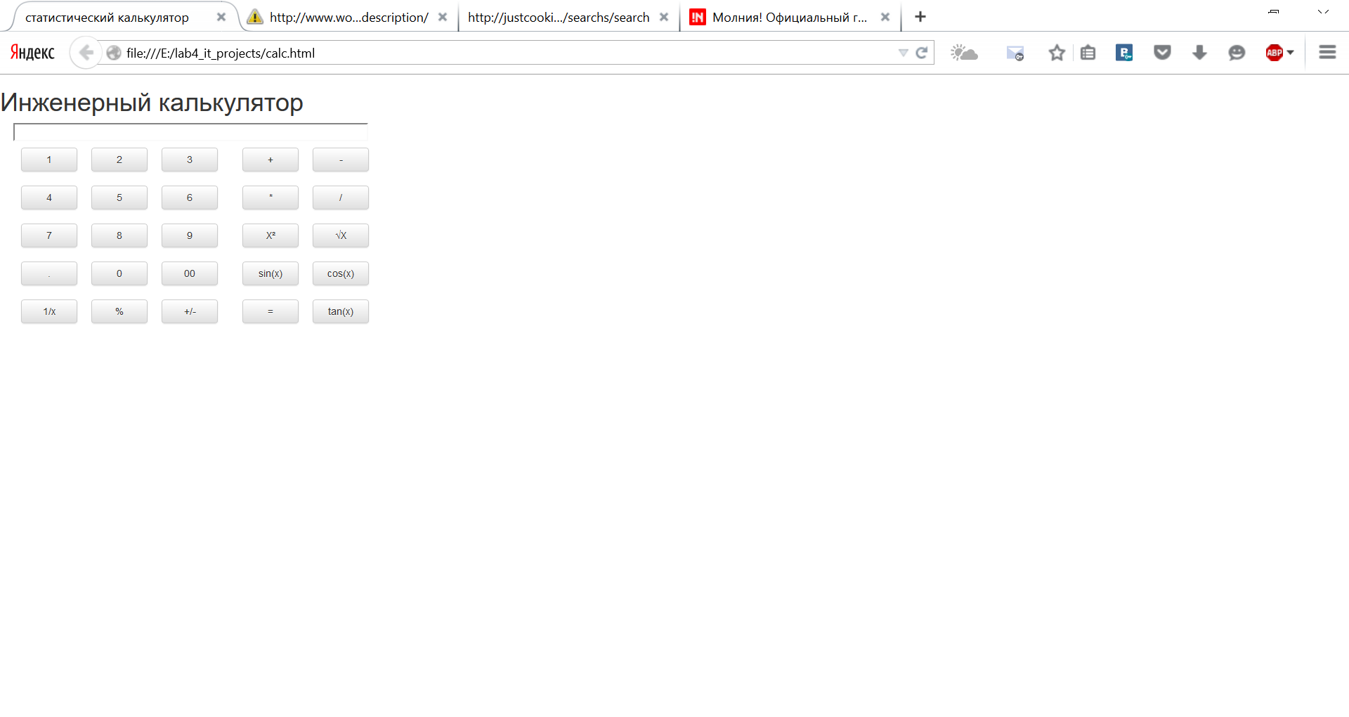

Рисунок 1 – Интерфейс проекта

Введем 10 и нажмем кнопку 1/х.

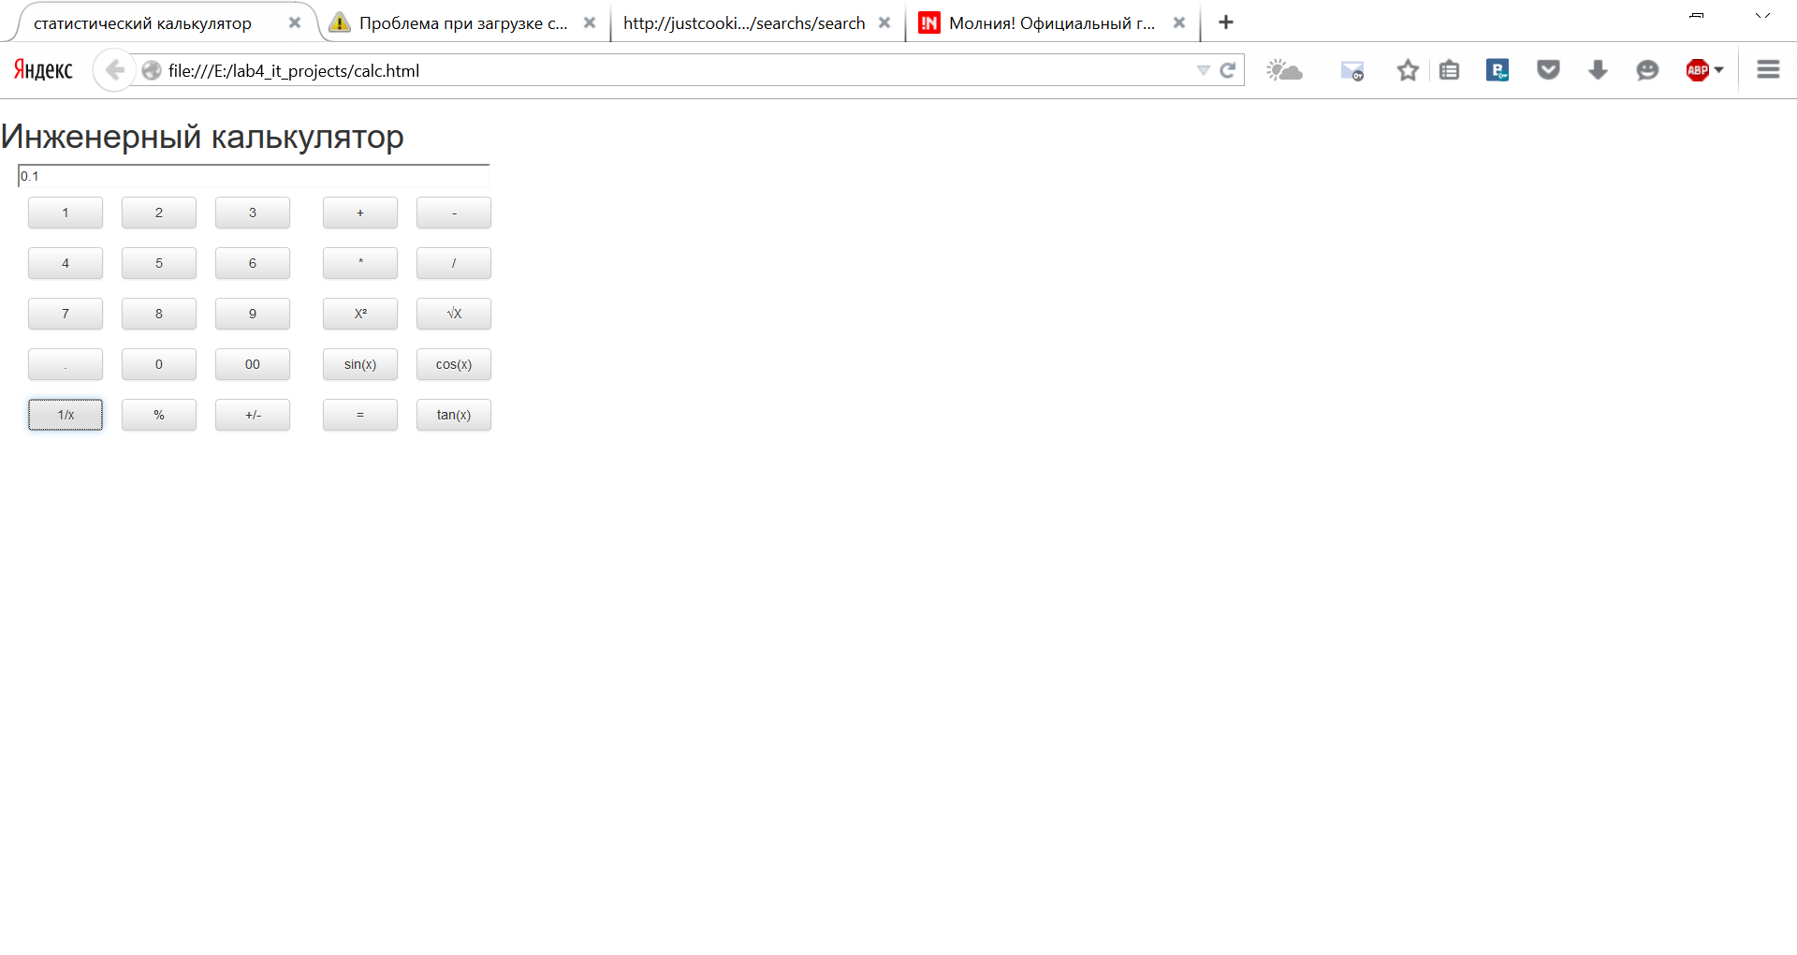

Рисунок 2 – Вычисление 1/х

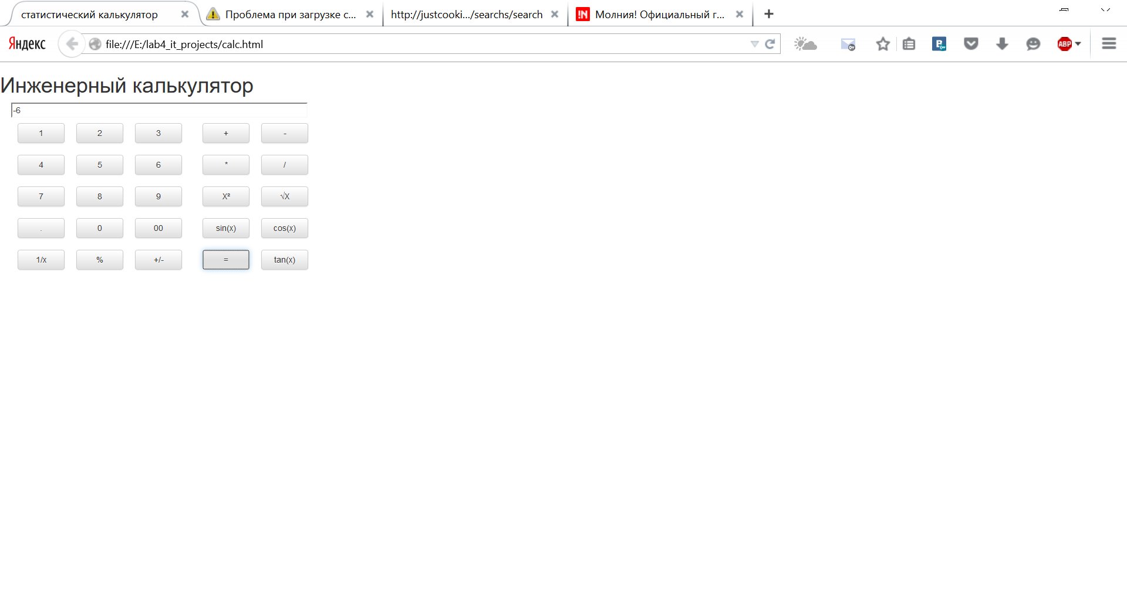

Рисунок 3 – Вычисление выражение 2*2-10

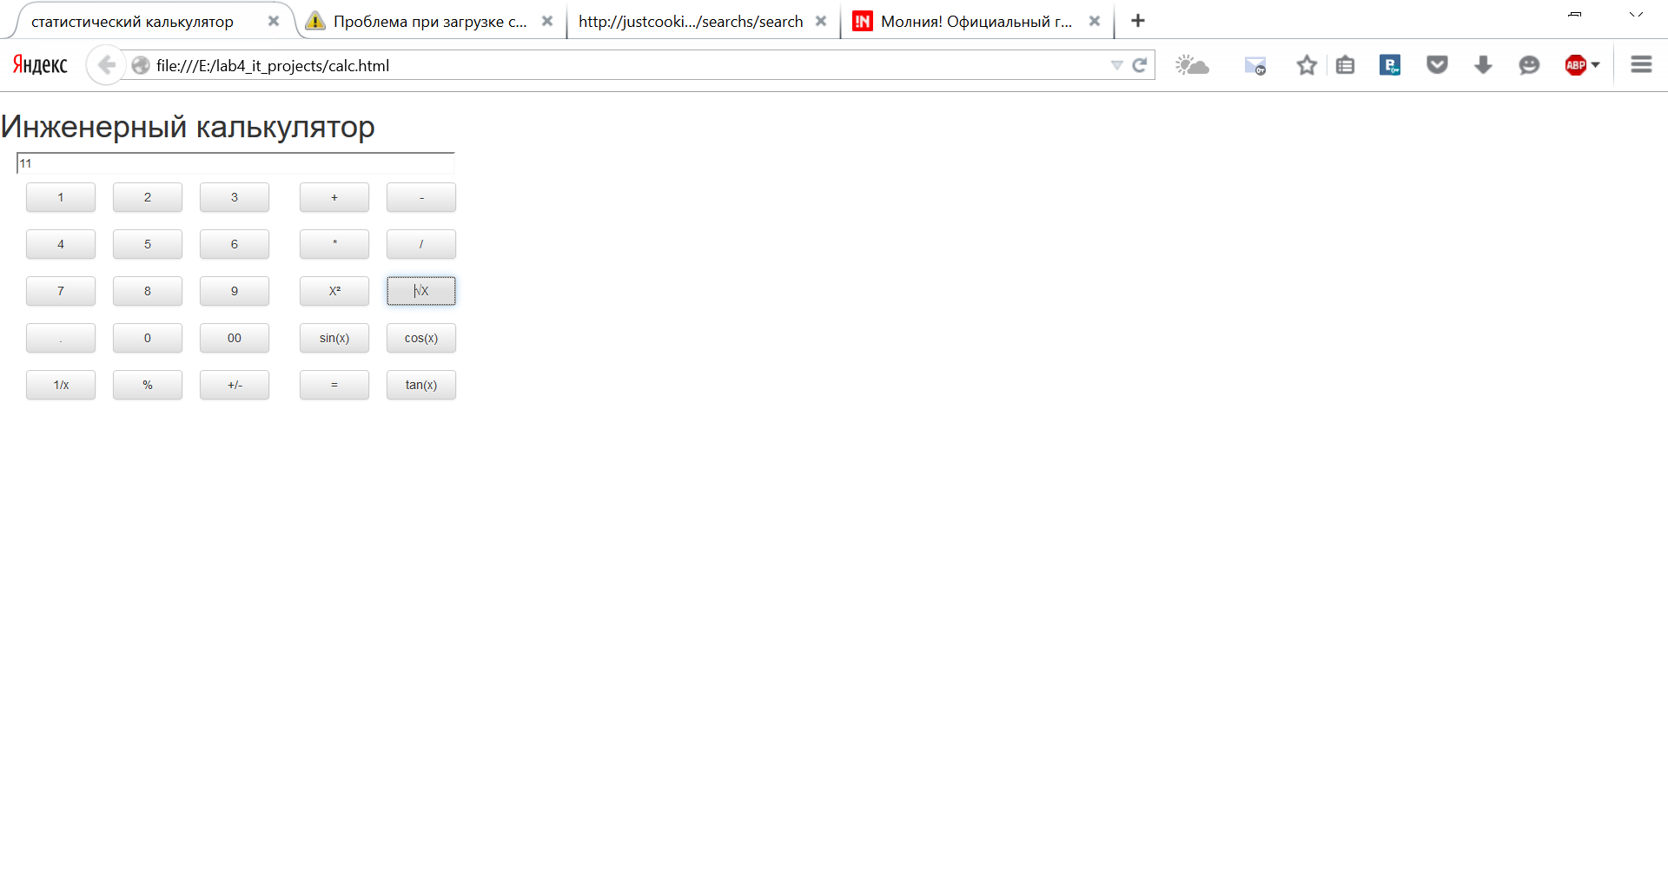

Рисунок 4 – Вычисление корня от 121

Результаты работы были выложены в репозиторий на GitHub

Вывод

В ходе выполнения лабораторной работы были получены навыки разработки проекта в команде. Был реализован простой калькулятор. Изменения фиксировались с помощью системы контроля версий Git. Обмен данными происходил с помощью удаленного репозитория GitHub. После завершения реализации было выполнено тестирование проекта.

Список использованных источников

1. Внесение изменений в чужой проект: <http://habrahabr.ru/post/125999/>
2. Справочная система Github: <http://help.github.com/>.